**Lab 1 : Install Virtual Machine and Configuring linux on it ( Type 2 virtualization).**

**Objective:**

To Install a virtual machine and configure linux using Type 2 virtualization.

**Theory:**

A virtual machine (VM) is a software-based emulation of a physical computer. VMs run an operating system and applications just like a physical computer. However, they are abstracted away from the physical hardware, providing several advantages for development, testing, deployment, and more.

**Procedure**

* **Download developer preview for macOS/Arm64(M1/M2) hosts.**
* **Browse the downloaded Vmware-workstation and double click in it.**

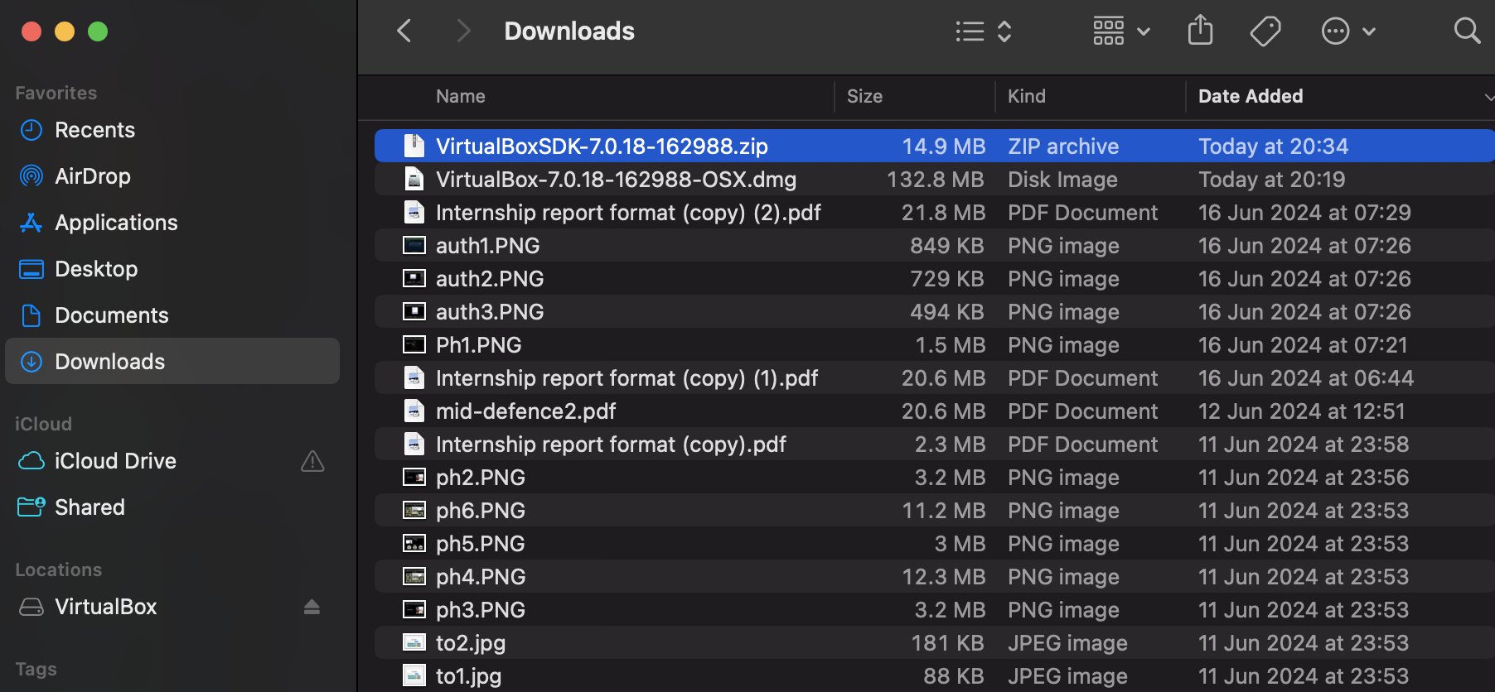

* **Press Continue**

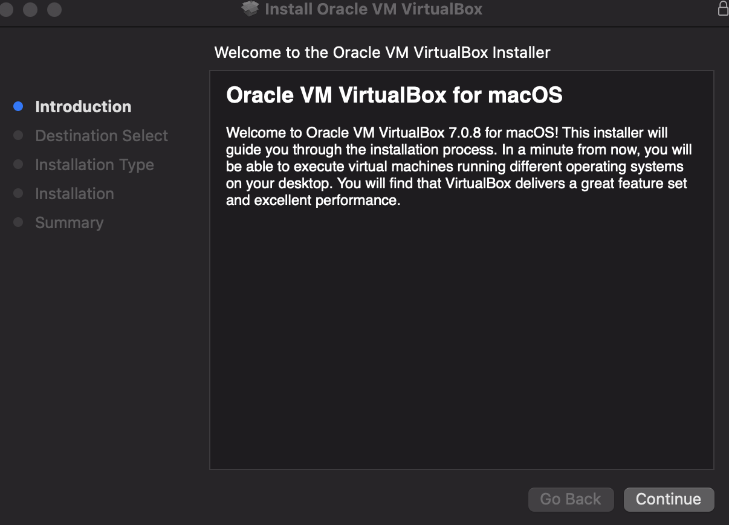

* Press Continue again

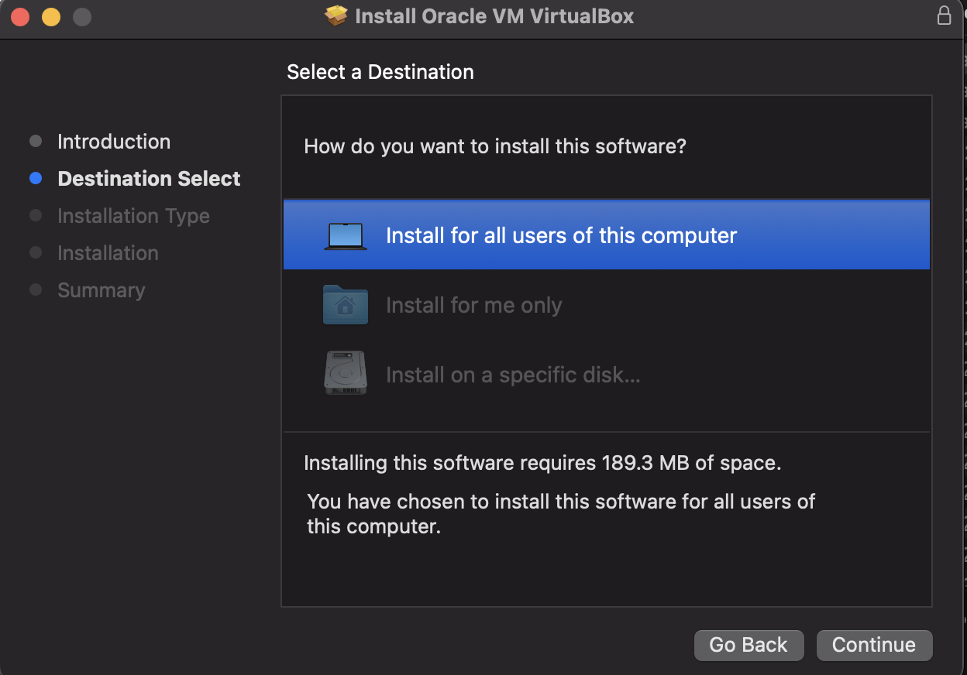

Click Intsall

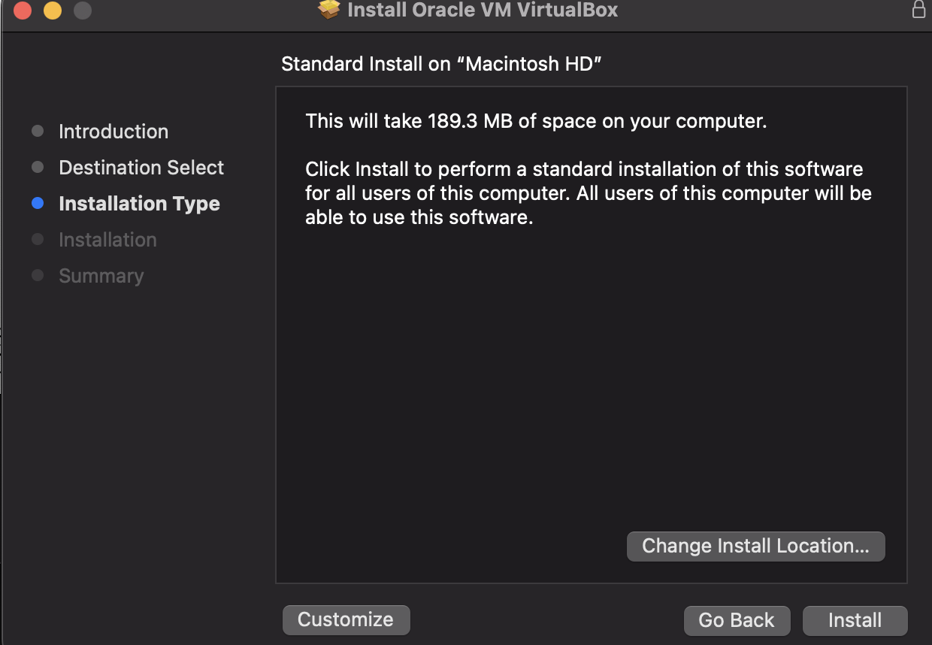

Installation Finished

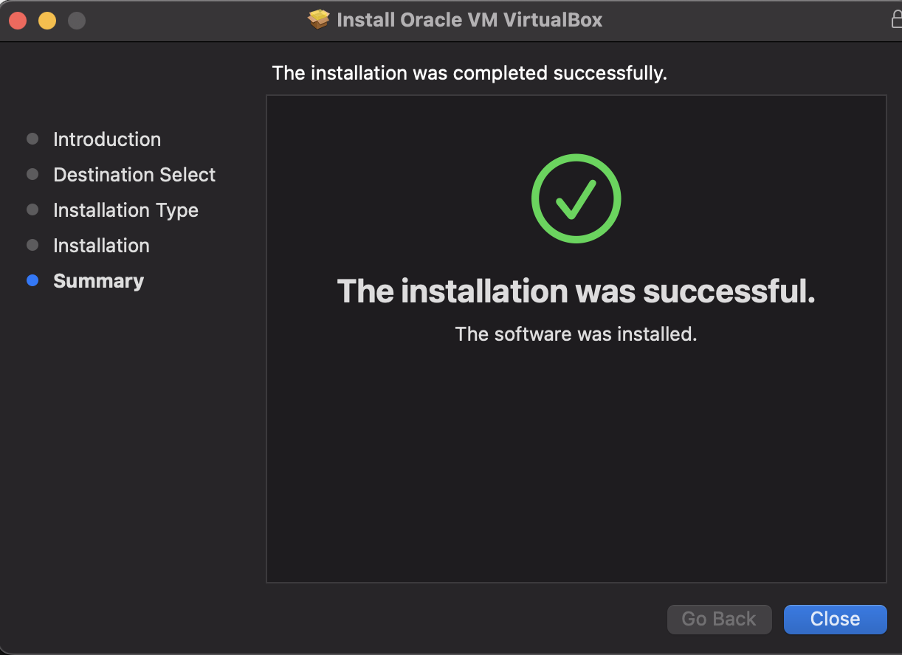

* Insert the iso file which has been downloaded

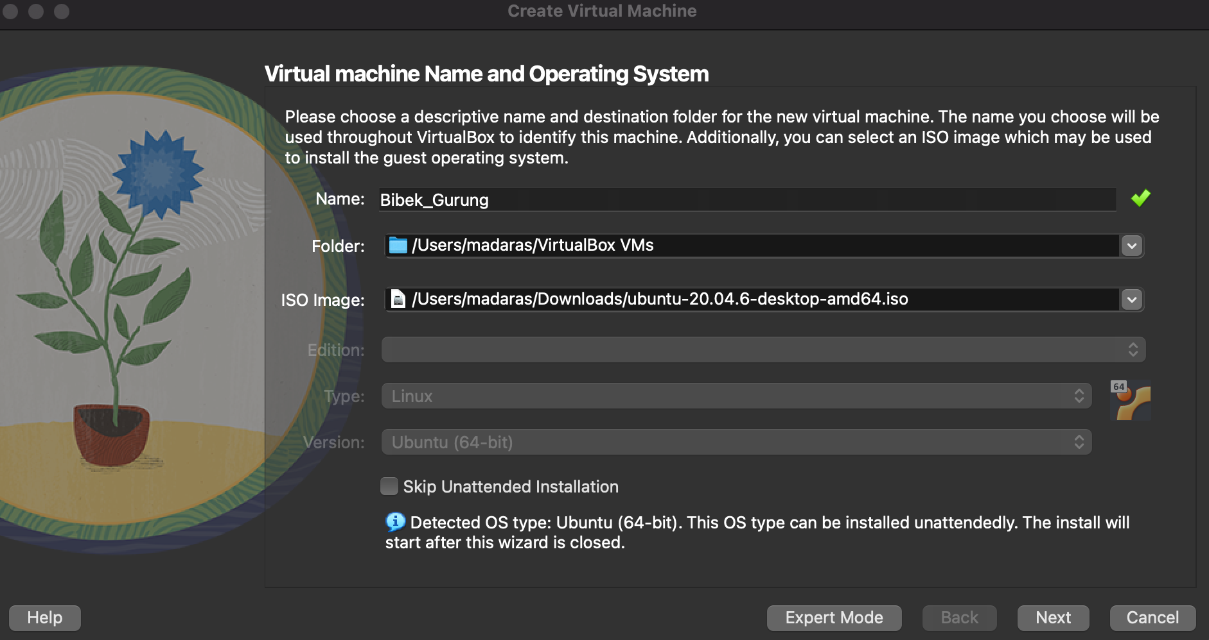

* Enter the username and Password properly and press the next button.

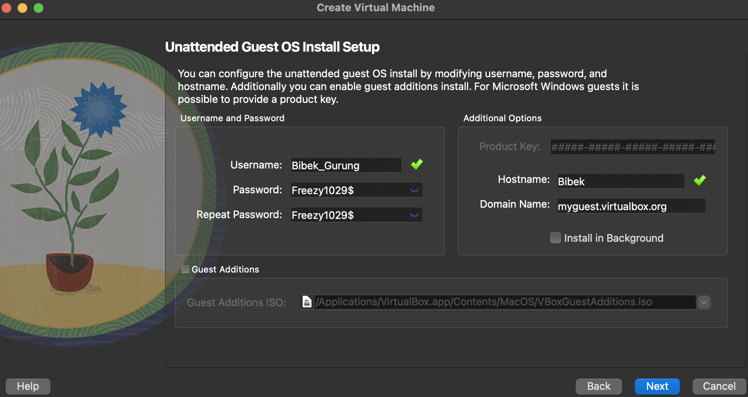

* Maximum disk size should be 20 GB but mine has only 18GB and after selecting the required CPU click on next

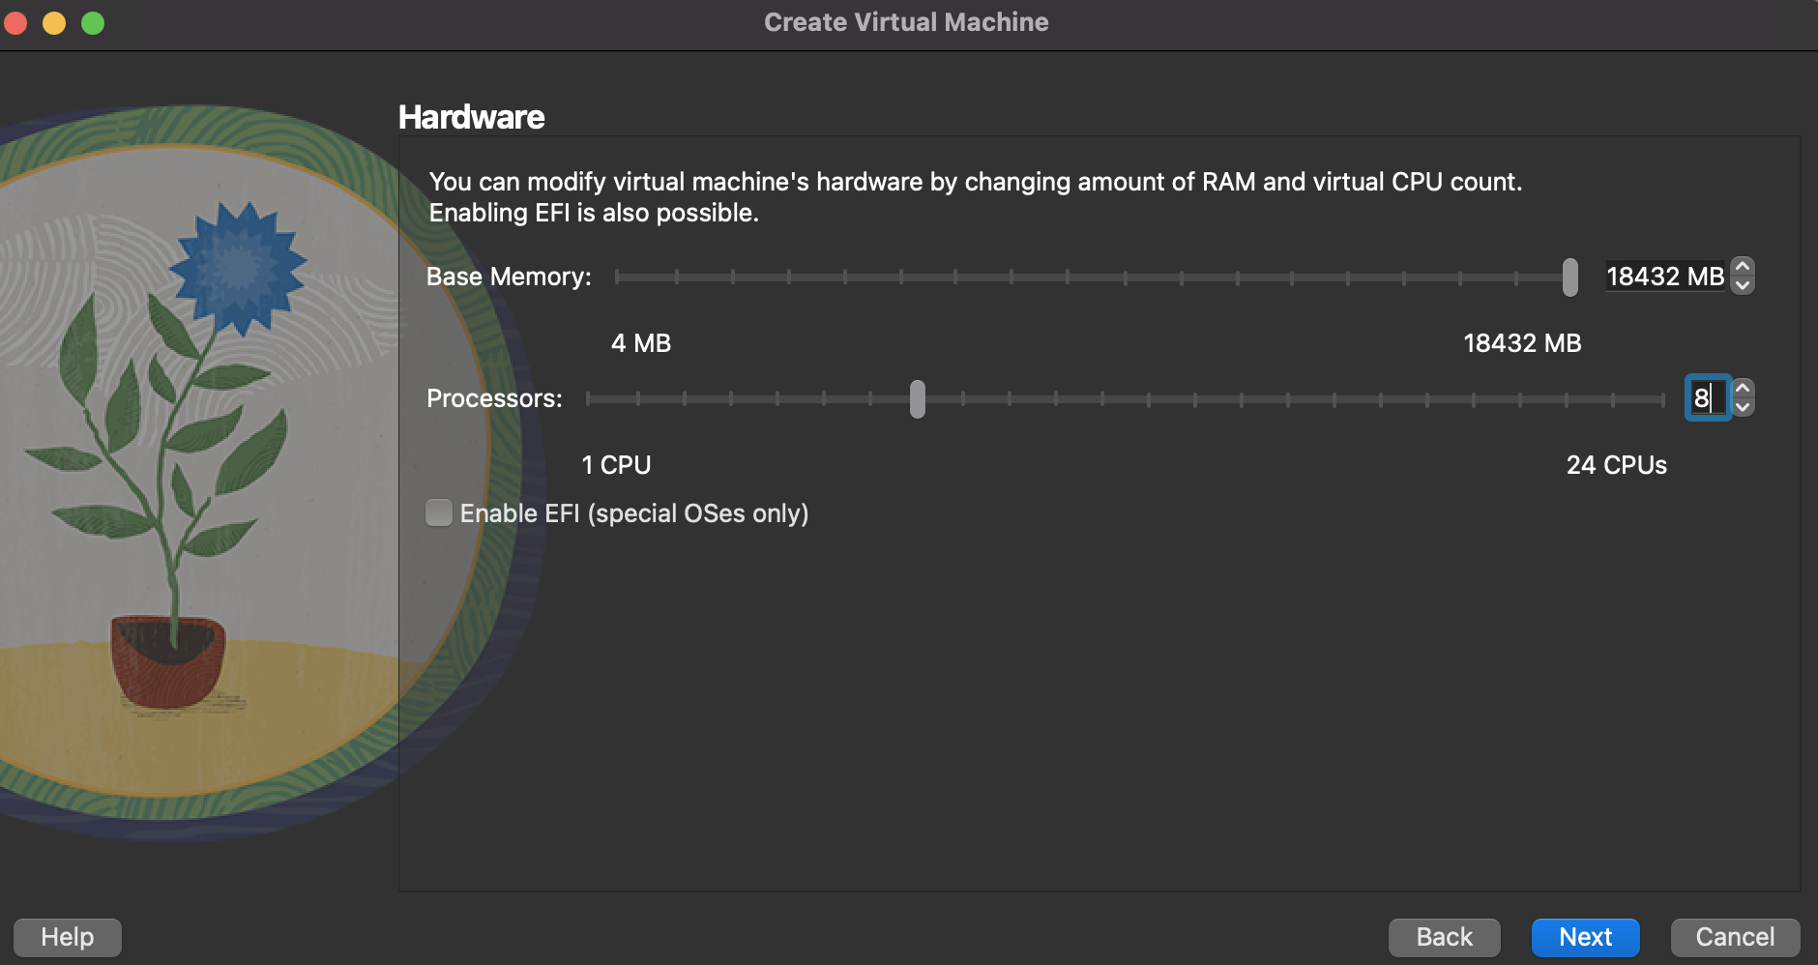

* Create a virtual hard-disk

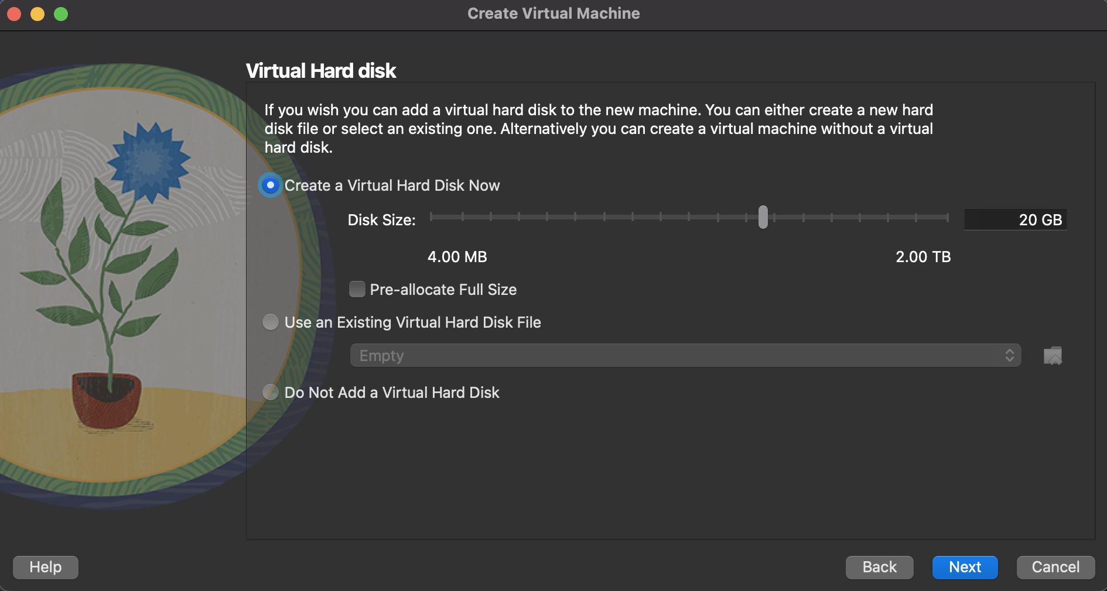

* You will get a summary and click finish

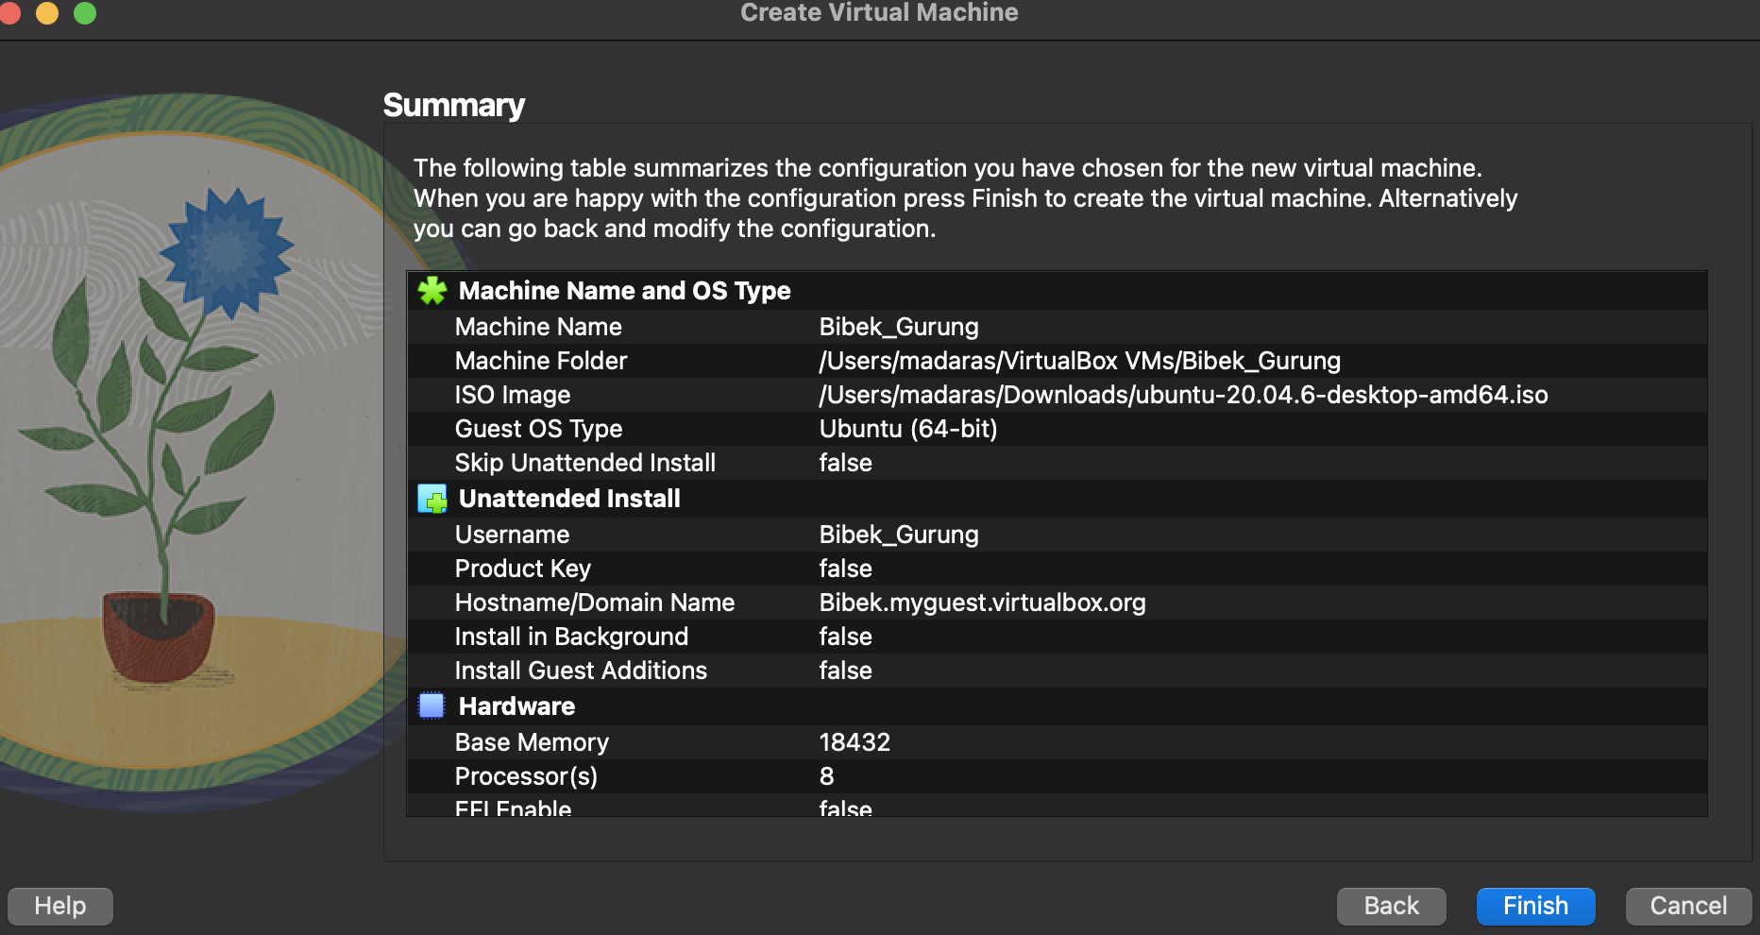

* Power on the virtual machine

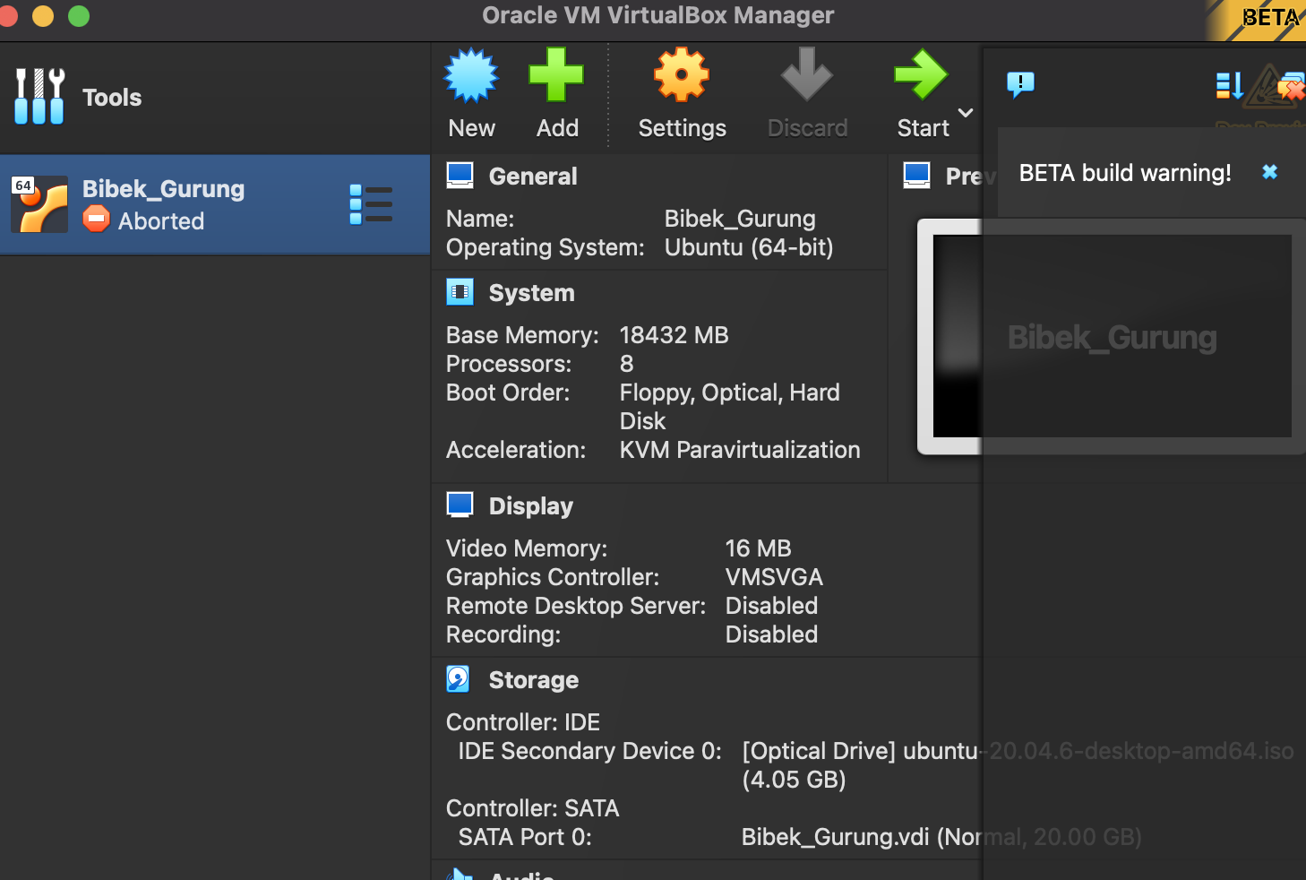

* Wait for the virtual to start

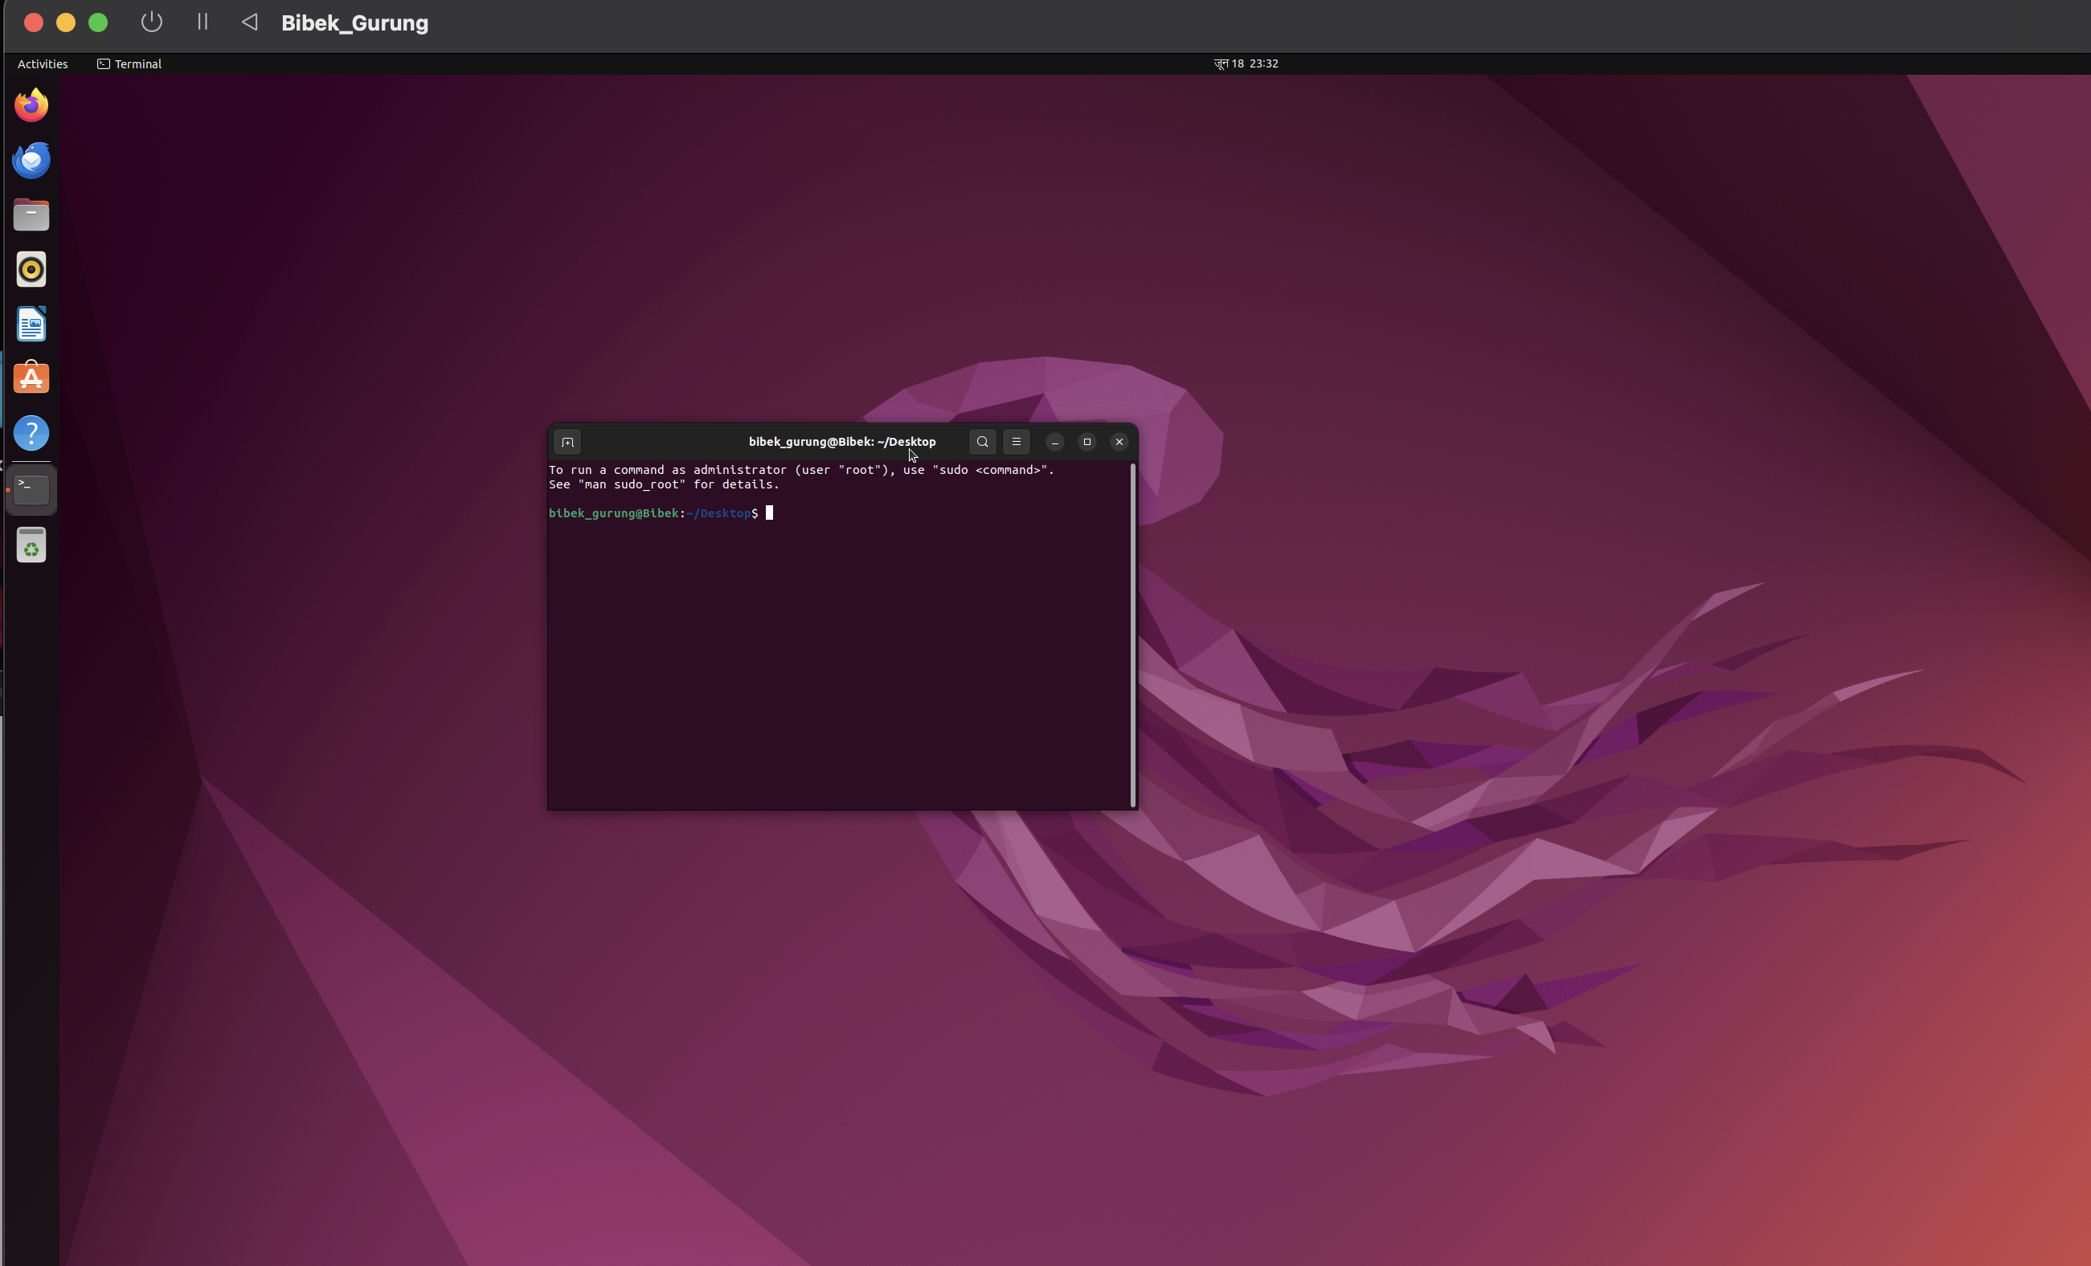

**Conclusion**

Cloud computing offers users measured services facilitated through virtualization. VMWare, a widely used application, enables the configuration of virtual machines within a single computer. These virtual machines operate as independent entities, laying the foundational groundwork for cloud computing.